Ness' Christmas Journey
Help document

Index:
1 Controls
2 Gameplay
3 Items
4 Enemies
5 Attacks
6 PSI Powers
7 Creators Notes
_______________________________________________________________
Section 1
Controls:

Arrow Keys Move
Shift Read Signs/Talk to people
SPACE Attack
1- 4 Change attacks
Ctrl Use PSI Power
Keypad 1- 3 Change PSI Powers

F1 Open Help Document
F2 Return to Title Screen
F3 Pause Game
F4 Switch Screen Mode
Esc Exit Game
_______________________________________________________________
Section 2
Gameplay:

The following is an explaination of the onscreen displays. Purple monkey dishwasher.
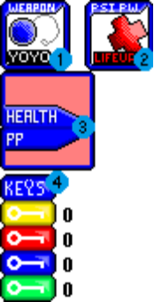

1. Weapon Display
Like... uh...
2. PSI Power Display
Uhh... yup...
3. Health and PP Display
Doo doo doo do dooo
4. Key Display
Keys are color coded to only fit doors of their color. Each number represents how many keys of that color you have.
_______________________________________________________________
Section 3
Items:


Cookie
Recovers very little HP.


Water
Recovers very little PP. (Hehehe...)

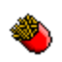
Fries
Recovers about 1/5 of your HP.


Psi Caramel
Recovers about 1/5 of your PP.

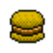
Hamburger
Recovers about half your HP.


Magic Pudding
Recovers about half your PP.


Keypad
These will become keys when all of the enemies in the room have been destroyed.
____________________________________________________
Section 4
Enemies:

Land Enemies:

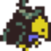
Crow
Crows are essentially weak but agressive enemies. They don't deal much damage, but they do have a tendency to hit many times.
They have low hp, which means that using PSI to take them out is a waste.

Recommended Attack: Yoyo
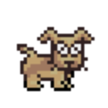
Dogs
Dogs are very aggressive and very fast, they inflict more damage than crows.
When they smell you nearby, they will charge at you continuously, unlike crows, dogs will not pause between charges, which makes running from them a bad idea.
However, dogs usually get blinded by rage and simply charge at your scent, which makes them bad for navigating corners and obstactles.

Recommended Attack: PSI Missle or PSI Fire

PSI Balls
These enemies are undefeatable, so you must dodge their PSI attacks. Since they cannot move, it may be a good idea to find cover when they shoot. PSI Shield will also prevent damage.


Smilin Spheres
These are somewhat dangerous enemies, they will move about randomly and charge at you ocasonally. They inflict some damage when they charge, but they also periodicaly launch PSI attacks, which will fly both at random directions, and at you. The best strategy is to keep moving and strike as much as possible. When the spheres are nearly finished, they get mad and become faster.

Recommended Attack: PSI Fire or PSI Spreadshot

Sky Enemies:


Blue and Red Eye Puff Clouds
These enemies will simply move at you at a slow speed, but there will be many charging at the same time, so you will need to fire fast or suffer damage.
Red Eye Puff Clouds are slightly stronger than Blue Eye ones.


Angry Clouds
These clouds will move towards you, stop, then release some cloud mites and then resume to move toward you. It may be a good idea to make sure you can defeat them before they release cloud mites, but they take a few shots before they will disperse.


Cloud Mites
These things are basicaly a annoyance rather than a threat. They do not cause much damage, but if you let fly about, they may swarm you in a large group and cause some major damage. Be aware that they only attack from the top, bottom left or right.
____________________________________________________
Section 5
Attacks:
Note: Only the Yoyo and PSI Missle are avalible from the start of the game. The other attacks are found during the game.

1
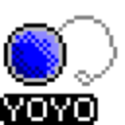
The yoyo is the only attack you can use when you have no PP, it will fly from you, then back to you. The power of the yoyo is the weakest of all attacks.
To cause extra damage, try to shoot the yoyo behind enemies, then have it tear through them when it returns.

2
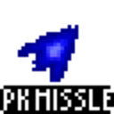
This attack launches a missle from you. It doesn't use very much PP.

3
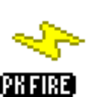
This attack launches a bolt that explodes into flames when it comes in contact with something. It does a bit more damage then the PSI Missle, but uses more PP.

4

This attack launches 4 shots from Ness that spread. This attack is very powerful, but uses a lot of PP and isn't very accurate at a distance. Try shooting it right up in an enemy's face for major damage.
____________________________________________________
Section 6
PSI Powers:
Note: You only start with PSI Lifeup when you start, the other powers must be gained during the game.

1

This will heal your health while it takes away from your PP.

2
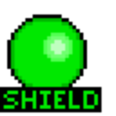
This will cast a shield over Ness to protect you from PSI Attacks. It can only take 3/4 the amount of hits Ness can, so make sure you still dodge attacks.
Warning: May cause slowdown to older computers!

3
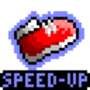
This will double your speed, it wears off once you leave the room you are in. It is handy for dodging attacks and outrunning enemies.
____________________________________________________
Section 7
Creators Comments:

I created this game specificaly for the starmen.net holiday funfest 2002, I put in a lot of effort into this game, I ripped as few sprites as possible, the following sprites are ripped:

Ness
All earthbound characters in the game
Crows
Dogs

I didn't rip the smiling spheres! Here's what they look like in the game!

Everything else was hand drawn by ME ME ME ME ME ME ME ME ME ME ME ME MEEEEEEEEEEEEEEEEEEEEEEEEEEEEEEEEEEEEEEEEEEEEEE!!!!!!!!!!!!!

Oh yeah, don't forget to get back at Jeff!!!

